1. Close all the routine which are opened in the Design Studio

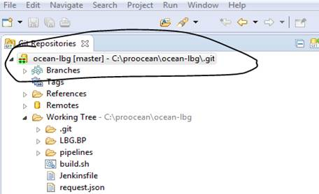

Please right click on the existing reposity and you will get the option of Delete Repository…

1. Once u click on delete reposity you will find the screen as displayed below.

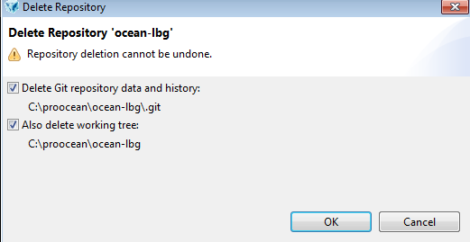

Tick both option as shown above and click ok, and press F5 to refresh.

This delete the existing repository.

Now please clone the reposity and steps given below.

Now we need to clone the git repository.

Once you’re at the home screen of Design studio you can find the clone a git repository(2nd option)

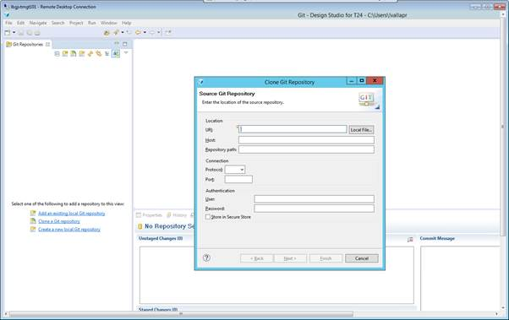

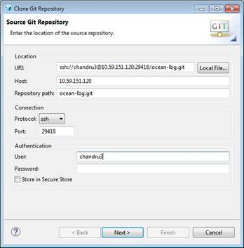

Host:10.59.151.120

Repository path:ocean-lbg.git

Repository name:ocean-lbg   (no .git at the end )

Protocol:ssh

Port 29418

User: id create in gerrit

Password: if you have given any password at time of public generation if not given please leave it as blank.

Than click on Next

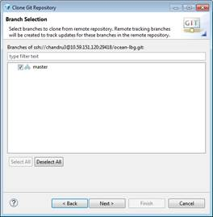

Once all the details are correctly given you can find the above window.

Now click on next

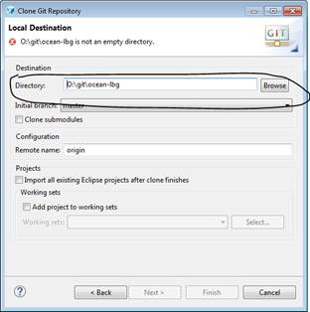

Now it will ask for the directory or folder where local repository has to be dumped, so please create the new directory and provide the path

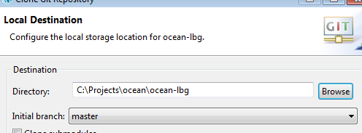

Once done the git will ~~push~~ all the source code to the local drive and you can see the progress. Actually clones the repo ( not an issue, but better to use correct term)

So these steps will complete the installation, configuring, cloning the GIT